

**The UK Current Account**

Speech given by

Ben Broadbent, Deputy Governor for Monetary Policy, Bank of England

At Directors Breakfast, Chatham House, London 29 July 2014

I would like to thank Alina Barnett and Richard Windram for research assistance and I am also grateful for helpful comments from other colleagues. The views expressed are my own and do not necessarily reflect those of the Bank of England or other members of the Monetary Policy Committee.

Good morning!

There has been a sharp, and welcome, bounce in economic activity in the UK. But it has been accompanied by an equally sharp deterioration in the balance of payments. From 1½% of GDP in 2011 the deficit on the current account – the combined balances for trade, asset income and transfers – widened to 4½% of GDP last year. That’s the second-highest annual figure since the Second World War (Chart 1). In particular, it is significantly higher than during any of the innumerable currency crises the UK suffered over the following thirty years or so. Last month, a piece in the Financial Times1 argued that Britain’s “notoriously weak trade position” was a threat to the economic recovery. Today I want to talk about the causes of, and context for, for the current account position. I will end up concluding that its significance depends in part on the health of a country’s net foreign asset position and, more fundamentally, on the trust in its institutions.

Perhaps the first thing to say is that the widening of the current account deficit is not, in fact, the result of a worsening trade performance. Despite a much weaker recovery in the UK’s trading partners than at home, the gap between exports and imports has actually narrowed slightly over the past few years (Chart 2). That’s due mainly to surprisingly weak imports (Chart 3). It’s possible that this reflects the lagged effects of sterling’s depreciation.

# Chart 1: Current account deficit has widened Chart 2: Trade deficit has narrowed

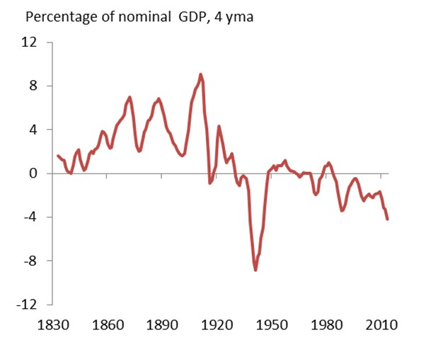 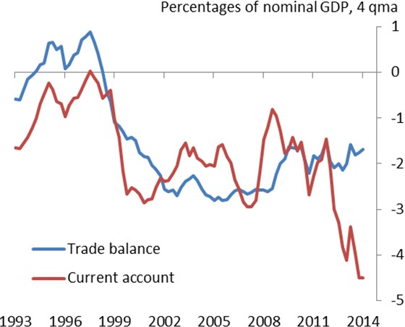

Source: Hills,Thomas, Dimsdale (2010) for data until 1949 and ONS for data between 1949 and 2012

Source: ONS

At any rate, the trade deficit has got a little smaller, relative to GDP, and the cause of the deterioration in the current account is, instead, a sharp drop in the net income received on the UK’s overseas balance sheet.

The spread between the annual yield on overseas assets – foreign assets owned by UK-based institutions – and that on UK liabilities (foreign claims on those UK institutions) has fallen by around 40bp over the past couple of years (Chart 4).

1 “UK economy: smooth sailing?”, Financial Times, June 17 2014.

# Chart 3: Import growth relatively low Chart 4: Net yield on foreign assets has declined

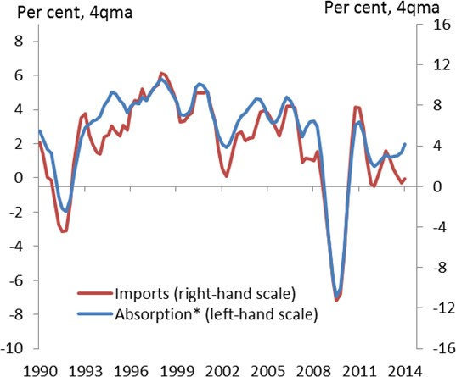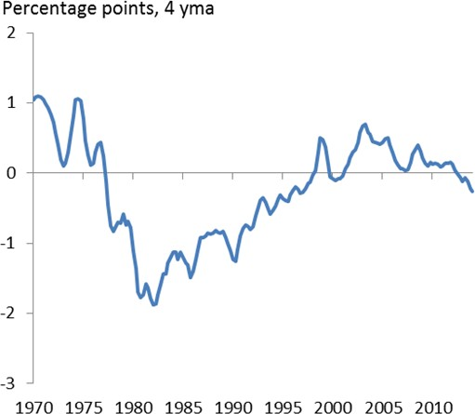

Source: ONS

* Absorption is defined as domestic demand plus exports

Source: ONS and Bank of England

Note: Net yield is calculated on book value assets and liabilities before 1990 and on marked to market values since. For further details see page 22 of the May 2014 *Inflation Report*.

That might not seem much. But when you have an overseas balance sheet as large as the UK’s, both sides of which are worth around six times annual GDP (Chart 5), shifts like these can matter. It is this balance sheet, and its consequences, I want to focus on today.

I will make three particular points:

First, while the UK has run a current account deficit most of the past twenty years, the stock of net foreign assets (NFA) has been broadly unchanged. This is because capital gains on the assets have exceeded those on liabilities:

*Current account balance*

∆*NFA = trade balance + transfers + net income + net capital gain*

*primary balance net total return*

To put it another way (using the lower bracketed terms), the net total return since the early 1990s – income plus capital gains – has been big enough to pay for a significant (2½-of-GDP) primary deficit over that period. At least in part, this reflects compositional differences across the two sides of the balance sheet: it is slightly “long” risky assets (UK investors own more equity assets abroad than do foreigners in the UK). That property, plus the fact that it is short the domestic currency – there are more sterling-denominated liabilities than assets – also means returns are volatile. Even when you plot them over 10-year rolling periods, as in Chart 6, total returns move around quite a bit. But over time, you would expect them to be slightly positive,

commensurate with the premium earned on risky assets. Marked to market, the UK’s net foreign asset position looks to be positive2.

Second, the net asset position has some bearing on the empirical relationship between the current account deficit and subsequent rates of growth. Countries with a healthier net foreign asset position are less likely to experience financial crises; they are also less prone to the precipitate reversals in current account deficits – “sudden stops” in overseas funding – that can prove very damaging for demand and economic activity. I don’t think we should be terribly surprised by this: just as they are to an individual institution, investors are more willing to cover a country’s deficit the sounder the underlying asset position. But it does mean that the interpretation of the deficit depends on its context.

# Chart 5: UK has large overseas balance sheet Chart 6: Net total return variable, on average +ve

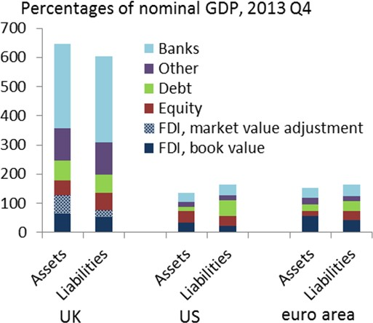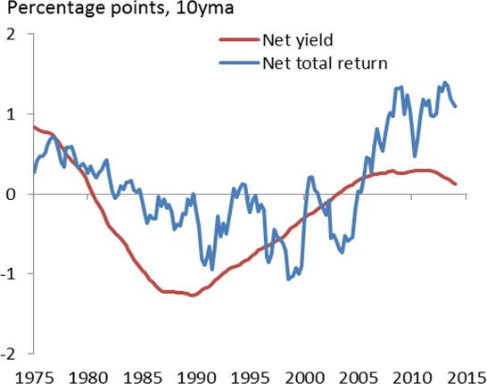

Source: BEA, ECB, IMF, ONS and IMF

Note: For details on how the FDI market value adjustment was calculated, see page 22 of the May 2014 *Inflation Report*.

Source: ONS and Bank of England

Note: Net total return and net yield are calculated on book value assets and liabilities before 1990 and on marked to market values since. For further details see page 22 of the May 2014

*Inflation Report*.

Third, the UK’s ability to earn more on its overseas assets than it pays on its liabilities may depend in part on the credibility of our economic policy. For many years after the 1976 crisis, right up to sterling’s ejection from the ERM in 1992 and the introduction of inflation targeting and rules-based fiscal policy that followed, domestic interest rates were significantly higher than in other developed countries. This meant the return on our liabilities – both the yield and the total return – was higher than on our assets (Charts 4 and 63). I don’t believe we’ve slipped back to that pre-1992 state. But, against the backdrop of what is a very large overseas balance sheet, the drop in net income in the past couple of years does illustrate the importance of a credible framework for macroeconomic policy.

2 Official estimates, which value Foreign Direct Investment at historic cost, currently show a slightly negative NFA position (-5% of annual GDP). But an estimate based on the market value of quoted equity is significantly higher (+35%). See page 22 of the May 2014 *Inflation Report*.

3 The deficit in the net yields is clear from Chart 4, which plots the four-quarter moving average. In Chart 6, the spread in total rates of return, including the volatile capital gains component, is plotted over 10-year rolling periods. So the figure for the 1980s corresponds to the entry for 1990Q1 (-0.9% per year). Note that this gives you only the impact of higher yields on the returns on the overseas balance

sheet. National income – those returns plus GDP – would also be affected by the impact of a higher cost of capital on domestic output.

I’ll go through the first two points in more detail. My conclusions will focus mainly on the third.

# The overseas balance sheet

Our overseas balance sheet wasn’t always as large as now. Official estimates go back to the late 1960s: at that time both foreign assets held by UK-registered institutions and foreign claims on the UK were worth barely 50% of annual GDP (Chart 7). Successive devaluations increased the sterling value of both sides and the value of the balance sheet grew to 100% of GDP by the early 1980s. The end of capital controls, and

the growth of international capital markets, led to a steeper increase over the following twenty years, to 300% of GDP in the early part of the last decade. The balance sheet then more than doubled in size during the banking boom that took place over the following few years (you can see the share of the balance sheet accounted for by UK-registered banks in Chart 84).

# Chart 7: Balance sheet has grown significantly Chart 8: Much of this reflects growth of banks

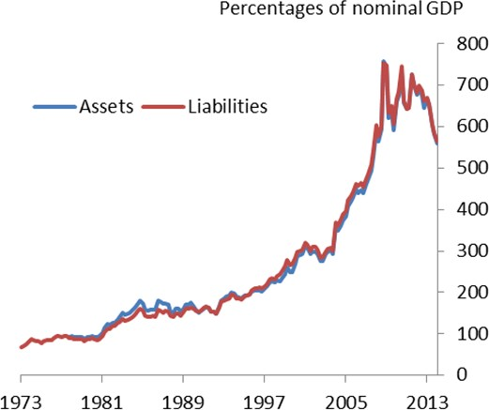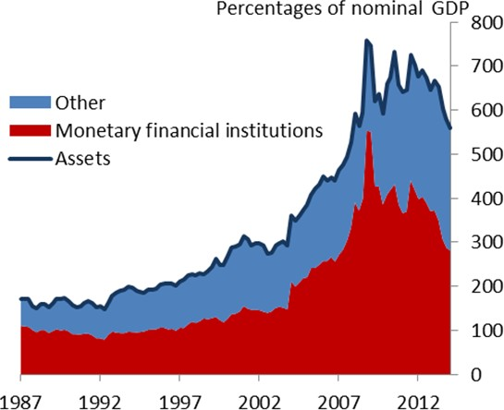

Source: ONS Source: ONS

What happened after that boom doesn’t need re-telling: we learned again the dangers of overstretched balance sheets, particular for institutions whose assets are riskier and less liquid than their liabilities (i.e. the banks).

I would caution strongly, however, against drawing a parallel between the position of an individual institution, within which there can be significant mismatches between assets and liabilities, and the risks involved in a country’s foreign balance sheet. What matters in this case is whether such mismatches exist across national borders. By and large, they do not – not, at least, on remotely the same scale as for an individual institution. What’s striking about Chart 5 is not how dissimilar are the compositions of the two sides of the balance

4 Note that “UK registered” does not mean “UK owned”. In 2007, according to estimates published by the Bank for International Settlements, around 40% of the overseas balance sheets of banks registered in this country actually belonged to UK subsidiaries of foreign-owned institutions. Even now, after the rapid shrinkage of international banks since the crisis, their balance sheets are worth around 100% of annual UK GDP, a third of the figure for UK-registered banks in total.

sheet, but how similar they are. This is the main reason for the tight co-movement of assets and liabilities in Chart 6.

That said, and although these charts barely reveal them to the naked eye, there are nonetheless some significant differences:

* Overweight risky assets. High-profile takeovers of British companies often generate a great deal of political attention. But the FDI and equity investments in the UK have long been outweighed by what UK-based institutions own overseas5. The imbalance means net returns are volatile: they rise and fall with global equity returns. It also means that, looking through these swings, and even if in aggregate net assets are zero, you’d expect on average to earn positive net returns, commensurate with the risk premium typically earned on these investments. To the extent they are in the form of capital gains rather than dividends, these excess returns wouldn’t show up in the current account.
* Overweight maturity: The bulk of the balance sheet, on both sides, is accounted for by fixed-income assets, either short-term deposits or longer-term debt. Today these are well matched. But for much of the past twenty years, the net position has been skewed towards longer-term debt and away from shorter-term deposits. To the extent there’s any slope in the global yield curve this imbalance will tend to generate small positive returns on the current account – UK institutions earn a “carry” (as with equities, this is merely the compensation for the extra risk involved in the position). The carry will eventually decline if yield curves flatten, although in the process the balance sheet will see net capital gains (again unrecorded in the current account).
* Underweight sterling: In many instances UK investments overseas are hedged against currency risk. But the hedging isn’t complete. For example, foreign reserve managers own significant amounts of UK government debt, all of it denominated in sterling, but the UK’s own official reserves are smaller. Some of the long-standing FDI investments, owned by UK-based multinationals or pension funds, are also unhedged. So the UK as a whole is underweight its own currency. There’s no reason to expect this to generate net returns over the future. But, ex post, it does expose the sterling value of the balance sheet to significant capital gains (losses) when the currency depreciates (appreciates).

These differences help to explain the recent pattern of returns. Weak growth in the UK’s trading partners, above all the euro area, has depressed interest and dividend receipts on foreign assets. Equity prices have nonetheless risen everywhere, resulting in net capital gains on a balance sheet that’s slightly long risky assets. On both sides the moves are larger than one might have expected – income has fallen by more than

5 The size of that gap depends on how you value these assets (see footnote 2). At historic cost, which is the basis for the official ONS, FDI and equity assets are currently worth only around 8% of GDP more than the equivalent liabilities. The Charts all use these official data. At market value, according to estimates developed by Bank staff, the gap is currently close to 50% of GDP.

global profits, capital gains have been larger than in global equity indices – but directionally, at least, they seem reasonable.

The compositional differences also explain quite a bit of the variation in net returns over longer periods of time. Chart 9 reproduces from Chart 6 the net total return on the balance sheet, only this time plots it over three-year rolling periods. The other line is an estimate of the portion of the gap due to these compositional differences. The detailed data that allow us to do this exist only from 1987, which is why the graph starts only in 1990. But, at least since then, the fit is reasonably good. You can see the effect of sterling’s depreciation in the early part of the sample – because the balance sheet is short the domestic currency this boosted net returns over that period – and the opposite effect of the re-appreciation some years later. The broad path of risky asset prices, up before the crisis and down since, is also apparent in both lines.

Yet there are still some gaps. The actual series is more volatile. At least since the mid-1990s, it is also slightly higher. Post-appreciation, realised net returns have been around 0.4% points a year higher than you can explain with compositional effects. And even without this “excess return”, you might wonder why international investors are happy to allow the UK as a whole to run this skewed balance sheet in the first place – or at least to do so without charging a higher cost of funding. Not everyone can borrow at the same rate as the government. But at least in recent years, sterling interest rates haven’t been much different from those from those in other countries (Chart 10). Indeed, there is some evidence that, during the euro crisis, gilts were being treated by international investors as one of the dwindling class of safe assets.

Why might this be? You find the same pattern – low sovereign interest rates and positive net returns – in the United States. And for that country, some economists6 have inferred that these represent payment for the status of the dollar in international transactions: it’s the monetary return on what Valéry Giscard d’Estaing – then foreign minister and later the president of France – once referred to as the “the exorbitant privilege” of having a reserve currency.

Maybe so. But if the UK does have such a privilege it’s probably not one it’s enjoyed forever. From the late seventies until the mid-1990s, it cost more to borrow in sterling than in other currencies and, on average, there were negative returns on the balance sheet (Chart 5). We don’t have the data to say whether this reflected compositional effects, but I doubt it. At least over the period as a whole, the real value of sterling was broadly stable and risky asset prices did very well. If anything, that would have led you to expect positive net returns. This suggests something else may have changed, in a way that affected net returns, during the 1990s.

I will return to this pattern, and to the institutional factors that might influence net returns, in the conclusion.

6 See, for example, Gourinchas and Rey (2005)

# Chart 9: Net returns partly due to compositional differences between assets and liabilities

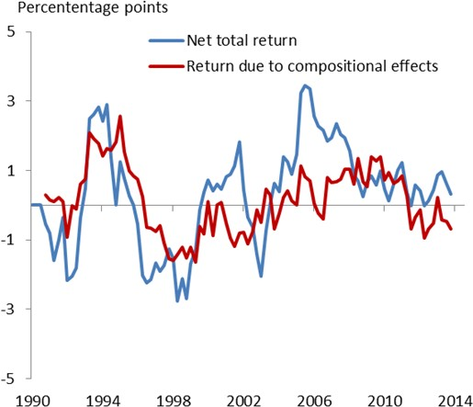

Source: ONS, Bank of International Settlements, Datastream, Bank of England and own calculations

Note: Net total return is calculated on book value assets and liabilities before 1990 and on marked to market values since.

# Chart 10: Yields on 10 year government bonds

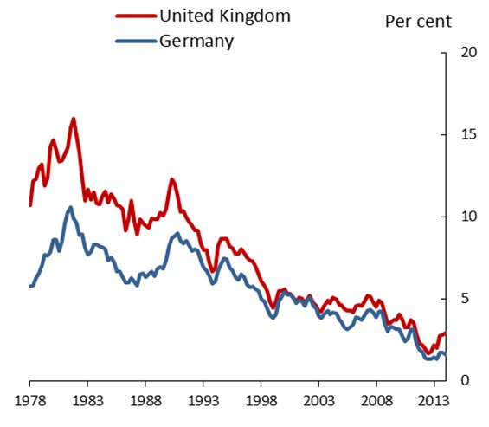

Source: OECD

# The current account and economic growth

In the meantime, I want to say a little bit about the relationship between the overseas deficit and economic growth. This is where we started. Arguably, it’s also closer to what Giscard d’Estaing meant by “exorbitant privilege” – he was referring not so much the excess return on the US’s foreign assets but its ability to run current account deficits for longer than might otherwise be the case. The claim was that the ability to issue a reserve currency made the US less prone to the sudden reversals in its overseas balance that were so damaging for other economies.

And it is, I think, these precipitate reversals – “sudden stops” in overseas funding that force violent corrections in domestic spending – that are the more relevant. Certainly, it’s hard to detect a simple, linear relationship between the current account deficit and subsequent rates of GDP growth. Chart 11 plots the raw data for OECD economies since 1955. A linear regression of one on the other gives a coefficient of less than 0.1 (the blue line): all else equal, 1% point on the deficit is associated with 0.1% lower expected growth the following year. Even that number shrinks if you allow for the influence of other cyclical variables – lagged growth of credit, for example, or of GDP growth itself (the red line). This suggests that the blue line is partly telling you that the trade deficit is cyclical: like other cyclical variables it’s high during expansions and therefore ahead of contractions.

Once you allow for a degree of non-linearity, however, the link is clearer. Chart 12 plots the path of growth before and during sharp corrections in the current account deficit, defined as an improvement of at least 2% of GDP within three years. As one might expect, these reversals are more likely the higher the starting point

(fewer countries experience jumps in the current account balance from a position of a surplus). Their implications for economic growth are also more evident than in the full sample.

# Chart 11: Deficit a poor forecaster of growth Chart 12: Better correlation for sudden corrections

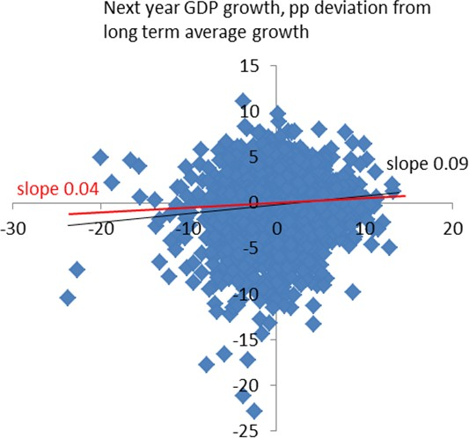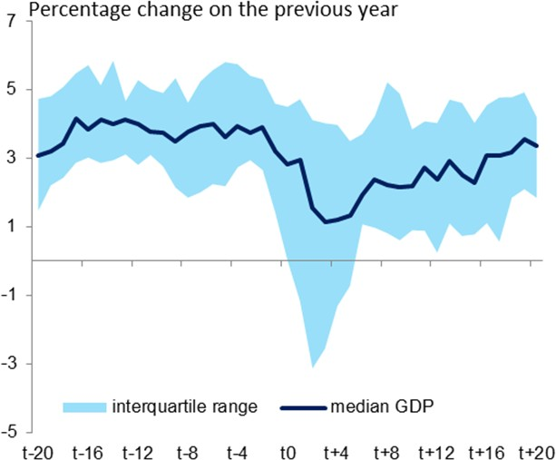

Source: OECD and Lane, Milesi- Firretti (2012) Source: OECD

Note: Sample includes 27 countries and 47 current account reversal episodes. t0 is the quarter the current account reached its trough.

Here too, however, context matters.

It turns out that the likelihood of a sudden reversal is smaller the healthier the underlying net asset position (Chart 13): unsurprisingly, international investors are more tolerant of a negative flow the better the underlying stock position7. As you can see from Chart 14, reversals have worse effects in emerging than in developed countries, at least in the first instance. The effects are also milder for countries with floating exchange rates. All these points are relevant for the UK.

7 What Chart 13 makes clear is that reversals nearly always occur in countries with negative overseas assets. What’s also true, however, is that current account deficits are also more common among these countries: the sample of countries in which the current account deficit is significantly negative and the NFA position is positive – the position of the UK – is relatively small. That said, there is sufficient variation to imply that, even for a given deficit, the NFA position still seems to matter. In a related finding, Catao and

Milles-Feretti (2012) show that the likelihood of external crises, defined by the need for IMF lending, is also linked to the NFA position. Using a longer sample, Jorda et al.(2011) find that, once you control for prior rates of credit growth, the current account position tells you little about the likelihood of a financial crisis.

# Chart 13: Sudden corrections more common in countries with negative NFA positions

**Chart 14: Short-term consequences for growth more severe in emerging economies**

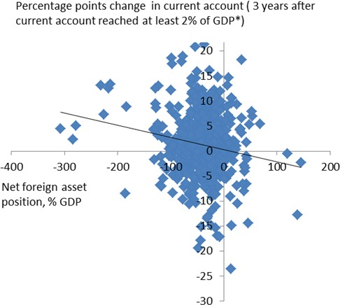 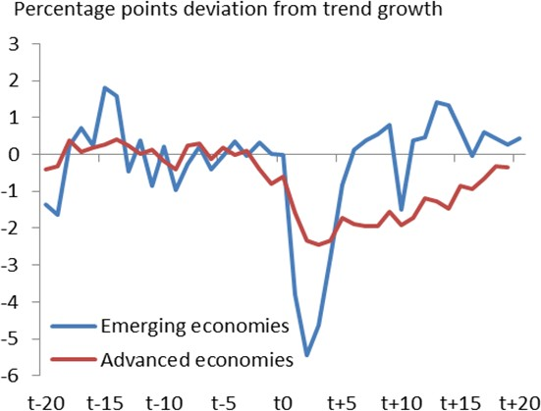

Source: Lane, Milesi-Firretti (2012) Source: OECD

Note: t0 is the quarter the current account reached its trough.

# Conclusion: credibility matters

As we saw right at the start the current account deficit is significantly larger than at the time of the UK’s many post-war currency crises in the 1950s, 60s and 1970s. Throughout those times, and particularly in the

run-up to what was probably the most dramatic crisis of all, in 1976, a persistent source of worry for British politicians and officials was what were called the “sterling balances”.

These were essentially foreign reserves, many of them held by former British colonies, built up during the Second World War. During that period the UK ran a cumulative current account deficit of over 50% of annual (1945) GDP, financed in large part by short-term borrowing. The result was that, by 1945, foreign governments had local-currency deposits worth 30% of annual GDP. These “sterling balances” were seen as a threat to Britain’s ability to meet its fixed-currency obligations under the Bretton Woods system. And although their value had already been eroded by inflation, they also played a central part in the 1976 crisis. Though it’s not clear who was first out of the door, official withdrawals began early that year, as the value of sterling began to fall, and accelerated through the spring and summer of 1976 (Chart 15).

Jim Callaghan, Chancellor during the 1967 devaluation and Prime Minister in 1976, saw the sterling balances not just as an important part of the crisis but its key underlying cause. It was these obligations, he believed, that had caused the vulnerability in the currency; and it was because sterling was depreciating that inflation was rising. Far from offering an “exorbitant privilege”, sterling’s residual status as a reserve currency, which would always entail large foreign holdings of sterling deposits, was seen as a curse.

# Chart 15: Exit from sterling balances during 1976 Chart 16: Sterling an unfavourable investment in

**mid-1970s**

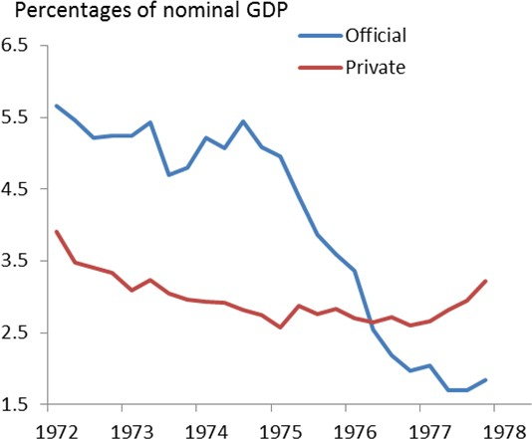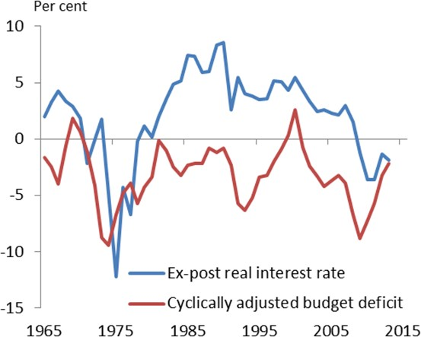

Source: Bank of England Source: ONS and Office for Budget Responsibility

Today, at least, I think most economists would probably see things the other way around. Liquid liabilities can amplify the risks from investor concerns about an institution’s underlying solvency. Just ask

Northern Rock. But it’s the fundamentals – in this case rapid inflation and a rising government deficit – that come first. At a time when inflation was 12% points higher than short-term interest rates, which were set by the government, when the government itself was running a structural deficit of almost 10% of GDP, and when there seemed little political appetite to incur the cost of bringing either under control, you could surely forgive the owners of these balances for wondering whether they were worth holding onto (Chart 16).

At any rate, many didn’t do so. And even if not its fundamental cause, the resulting withdrawals were an accelerant of the crisis through that year. By the time official interest rates did start to go up aggressively, in the autumn of 1976, the government was already in negotiations for a loan from the IMF, with all its stringent conditions attached.

The 1976 crisis obviously had a momentous political impact. I think you can also see its economic effects, for many years afterwards, in the cost of sterling debt. Inflation was subsequently brought under a degree of control, during the early 1980s. But, with inflation expectations relatively high, sterling interest rates remained well above those in the rest of the developed world, and for many years there was a significant net deficit on the UK’s overseas balance sheet. That only started to turn around during the 1990s when, after yet another sterling crisis, in 1992 – this one related to our short-lived membership of the European Exchange Rate Mechanism – the UK adopted first an inflation target and then a rules-based approach to fiscal policy.

There were surely other contributors to the turnaround. It was during the 1990s that fast-growing emerging economies started to have a positive impact on global activity and risky asset returns. Because they had a

higher propensity to save, they also contributed to the decline in global interest rates. Both trends will have profited the UK’s overseas balance sheet. The years from 2002-07 also saw an extraordinary boom in the activities of international banks, many of them based in the UK. If these institutions were taking more risk onto their non-UK balance sheets than at home – and that’s what the pattern of subsequent losses would suggest – perhaps it’s not surprising that, at least until the disaster that followed, there should have been a corresponding excess return.

And yet what is striking is that, even since the crisis, the UK’s overseas balance sheet has continued to perform relatively well. Despite being long equity and short debt, despite there being a far greater quantity of foreign-held sterling deposits in 2008 than there were sterling balances in 1976, foreign assets have continued to pay out more than foreign claims on the UK. And to say this partly reflects the depreciation – which, arithmetically speaking, it does – only begs a question about how that could have happened without putting pressure on sterling risk premia and interest rates, as it did after the 1976 crisis. I suspect that the answer lies, in part, with the institutional reforms of the 1990s and the rules-based approach to macroeconomic policy they established.

None of this means that today’s deficit is irrelevant for growth. It exists partly because the rest of the UK-trade-weighted world, the rest of Europe in particular, hasn’t yet recovered as rapidly. If the global economy remains sluggish, it will inevitably be harder for an open economy like the UK to achieve both

strong and balanced growth. That’s why the IMF judged after its recent Article IV consultation that, relative to its long-run sustainable level, sterling’s exchange rate is “modestly overvalued”. It’s also, in part, why the MPC expects UK output growth to soften a little over the future.

But that’s a long way from saying the current account deficit poses some independent, existential threat to UK growth. For one thing, it has been outweighed in the past couple of years by capital gains on the overseas balance sheet, and although their size is unusual, their direction is not. We know too that having a balanced net asset position seems to reduce the threat from a large current account deficit, as does a floating currency. Most important, the UK has in place a hard-won policy framework that didn’t exist when it went through the traumas of the 1976 crisis. This is something that should never be taken for granted.

**References**

**Catao L. and G. M. Milesi-Ferretti**, 2013, “External liabilities and crises”, IMF working paper 113.

**Gourinchas O. P. and H. Rey**, 2005, **“**From world banker to world venture capitalist: US external adjustment and the exorbitant privilege”, NBER Working Paper No. 11563.

**Hills S., R. Thomas and N. Dimsdale**, 2010, “The UK recession in context - what do three centuries of data tell us?”, Bank of England Quarterly Bulletin, 2010 Q4.

**Jorda O., M. Schularick and A. Taylor**, 2011, “Financial Crises, Credit Booms, and External Imbalances: 140 Years of Lessons”, IMF Economic Review, Vol. 59, No.2

**Lane P. R. and G. M. Milesi-Ferretti**, 2012, "External adjustment and the global crisis", Journal of International Economics, Elsevier, vol. 88(2), pages 252-265.